Scenario ID : 1
valid Login

Test Steps:

1. Open pyCharm app
2. Open PyCharm project
3. Open script.py
4. Install Selenium - Python- m pip install selenium
5. Import Selenium code
6. Open Chrome - https://the-internet.herokuapp.com/login
7. Navigate to form Authentication
8. Enter username & password
Username:Standard_user
Password:Wrong_123
9. Click login and verify successful login
10. Verify the success message
11. Click logout
12. Run the complete python automation

Screenshots:

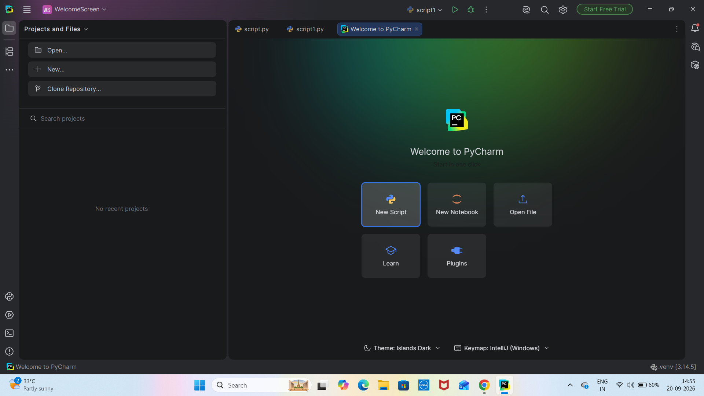
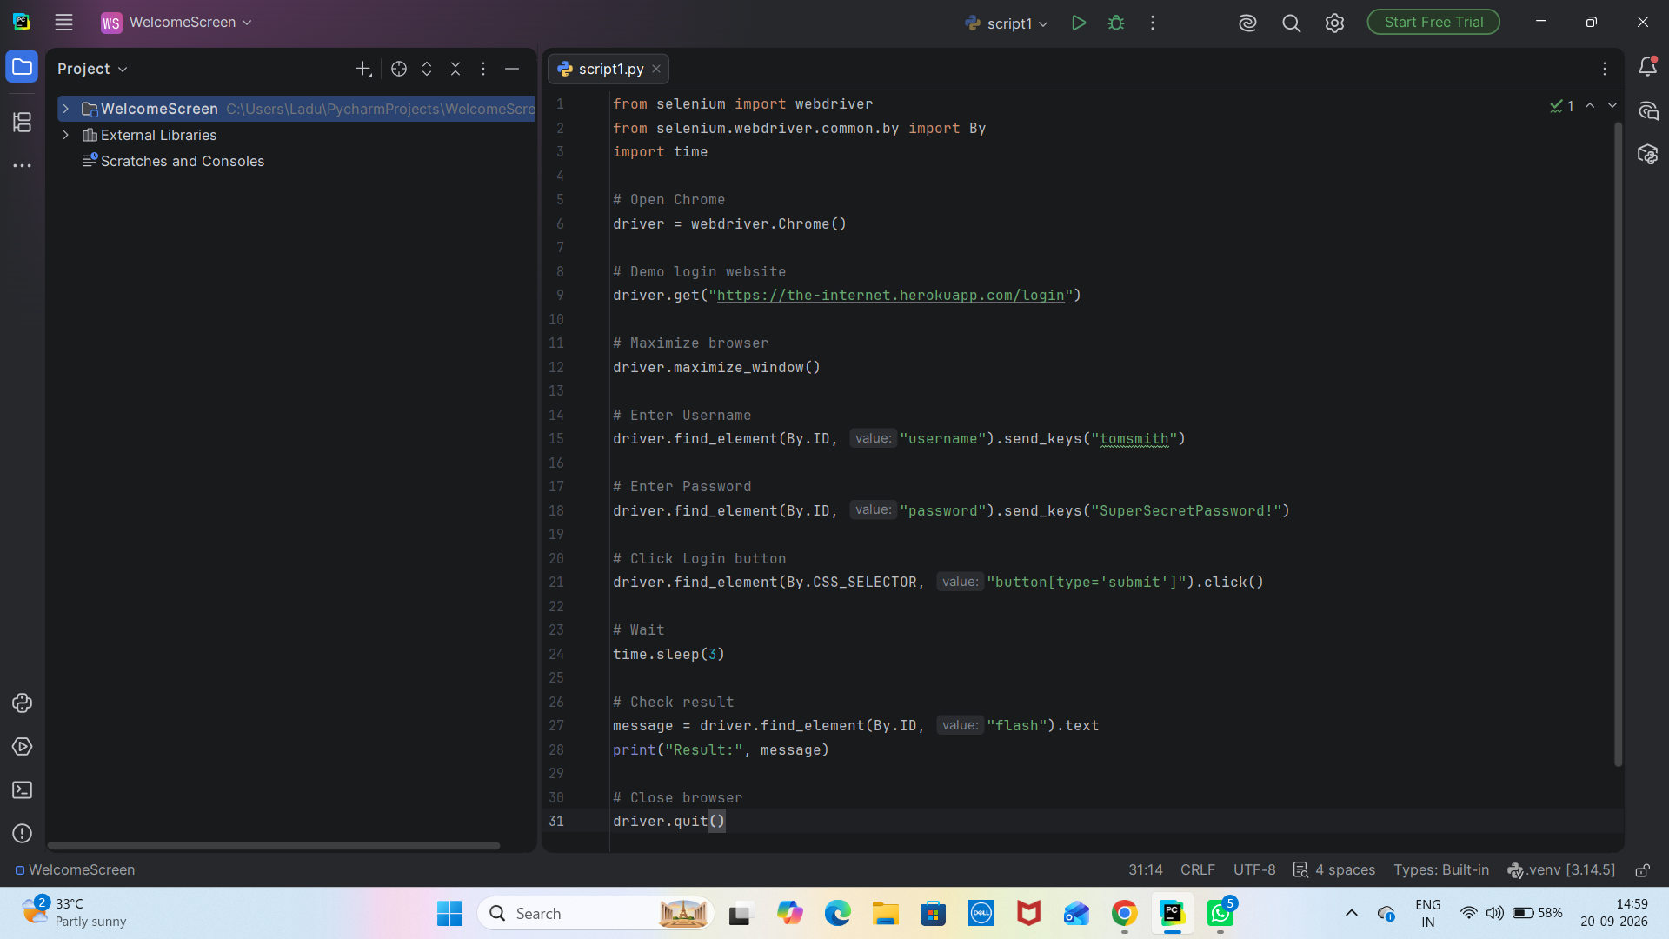

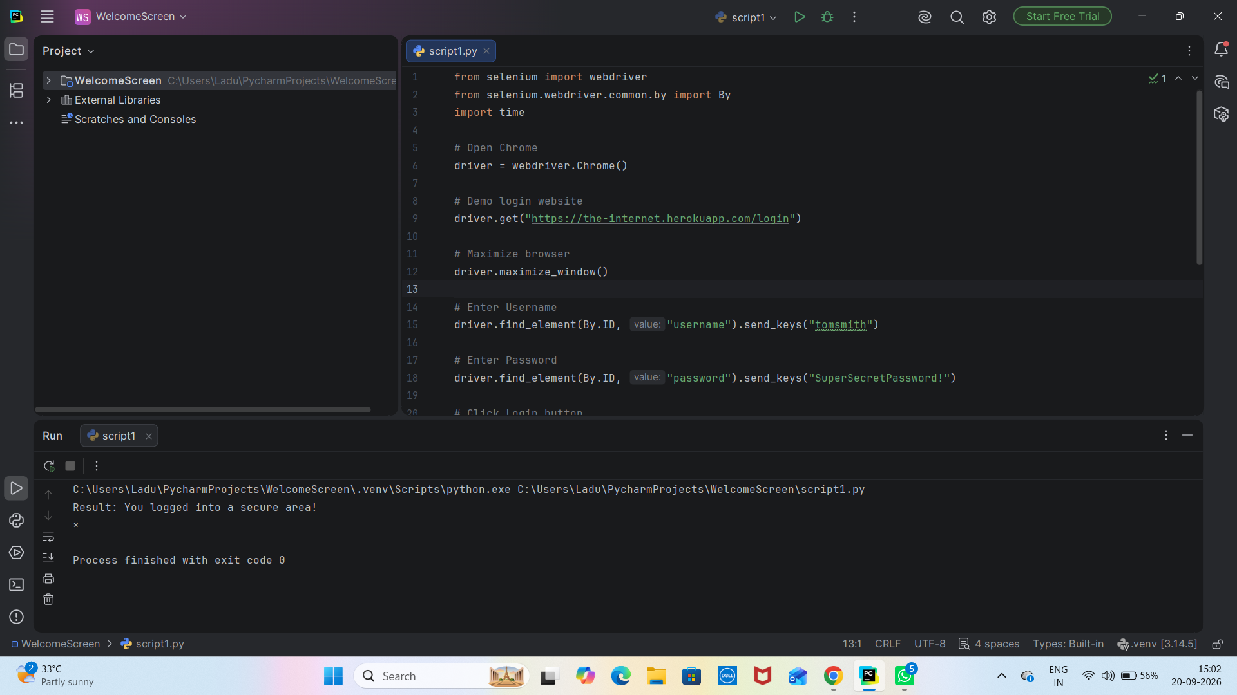

Scenario ID : 2
Invalid Password

Test Steps:

1. Open pyCharm app
2. Open PyCharm project
3. Open script.py
4. Install Selenium - Python- m pip install selenium
5. Import Selenium code
6. Open Chrome - https://the-internet.herokuapp.com/login
7. Navigate to form Authentication
8. Enter username & Invalid password
Username:Standard_user
Password:wrong123
9. Click login and verify successful login
10. Verify the success message
11. Click logout
12. Run the complete python automation

Screenshots:

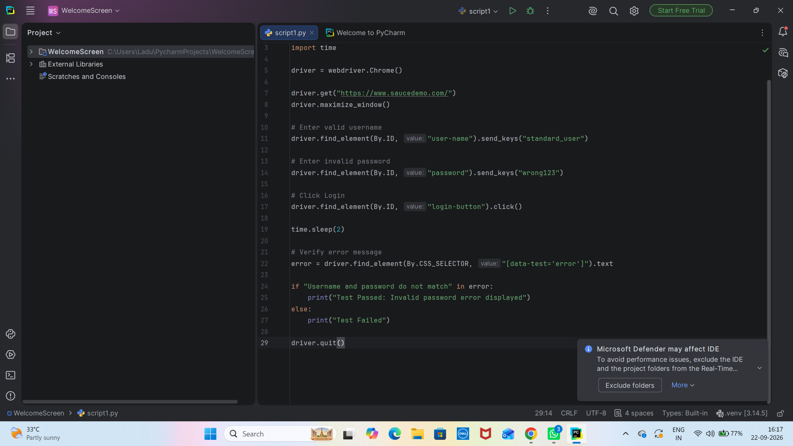

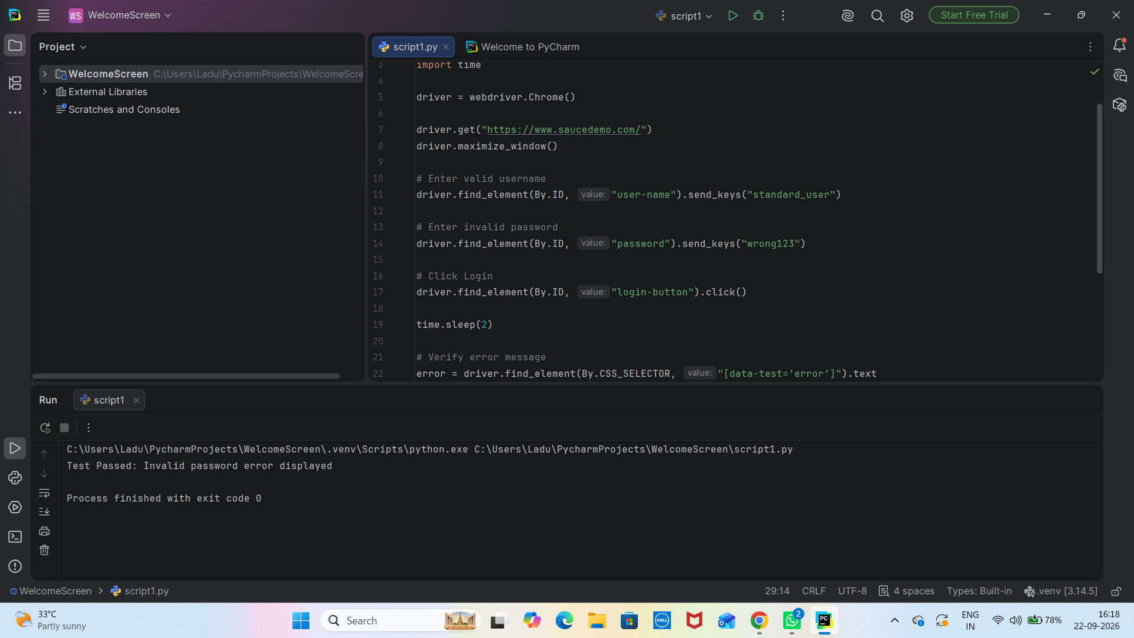
Scenario ID : 3
Invalid Username

Test Steps:

1. Open pyCharm app
2. Open PyCharm project
3. Open script.py
4. Install Selenium - Python- m pip install selenium
5. Import Selenium code
6. Open Chrome - https://the-internet.herokuapp.com/login
7. Navigate to form Authentication
8. Enter Invalid username & password
Username:Wrong_user
Password:wrong123
9. Click login and verify successful login
10. Verify the success message
11. Click logout
12. Run the complete python automation

Screenshots:

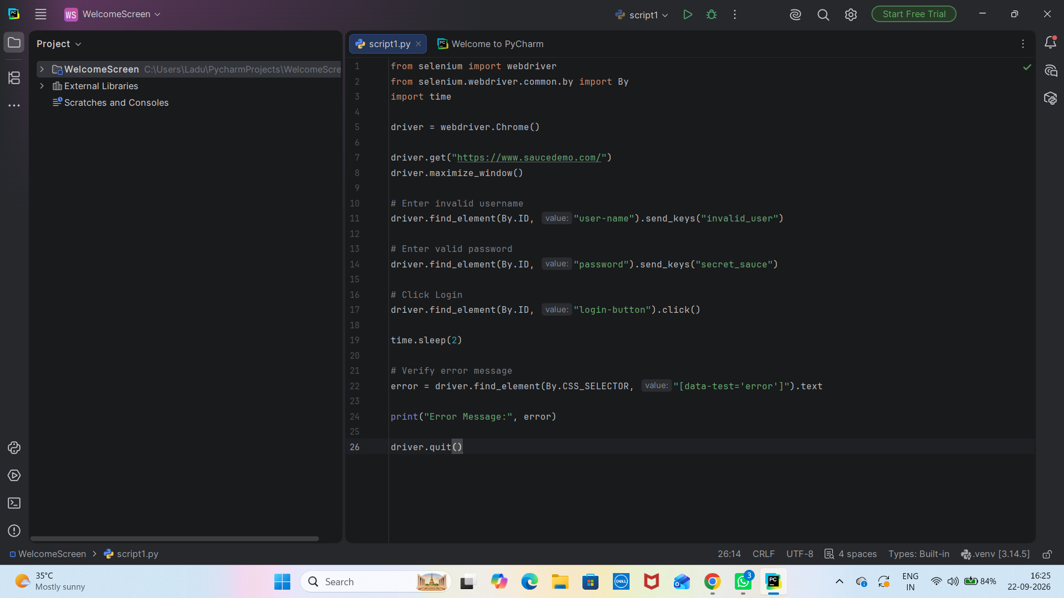

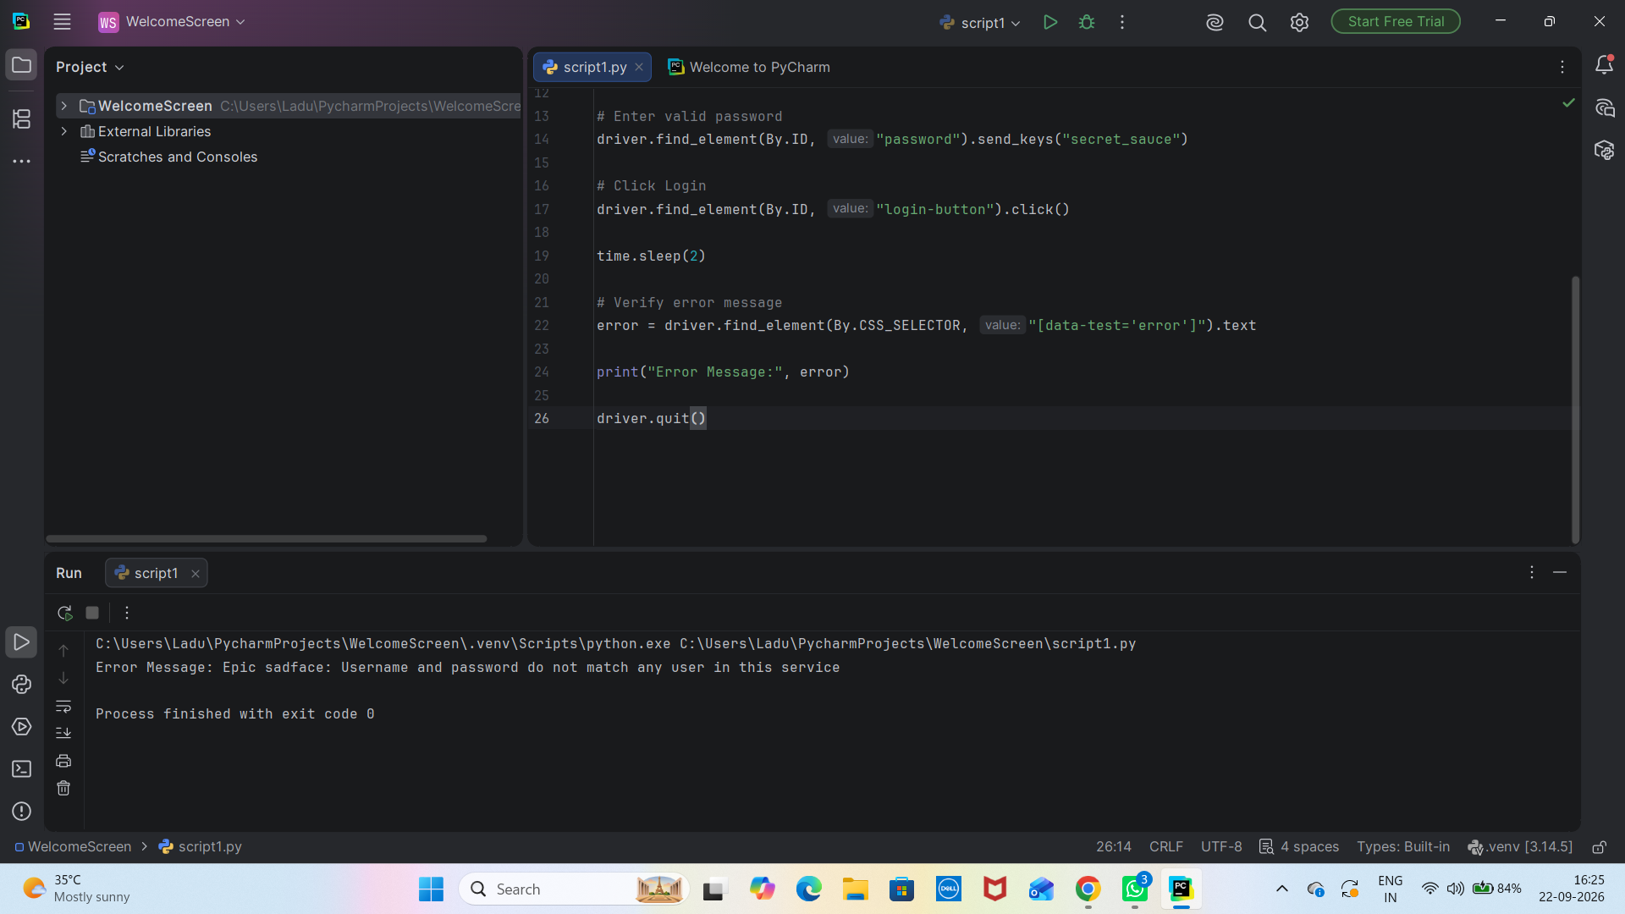
Scenario ID : 4
Empty Password

Test Steps:

1. Open pyCharm app
2. Open PyCharm project
3. Open script.py
4. Install Selenium - Python- m pip install selenium
5. Import Selenium code
6. Open Chrome - https://the-internet.herokuapp.com/login
7. Navigate to form Authentication
8. Enter username & password
Username:Standard_user
Password:
9. Click login and verify successful login
10. Verify the success message
11. Click logout
12. Run the complete python automation

Screenshots:

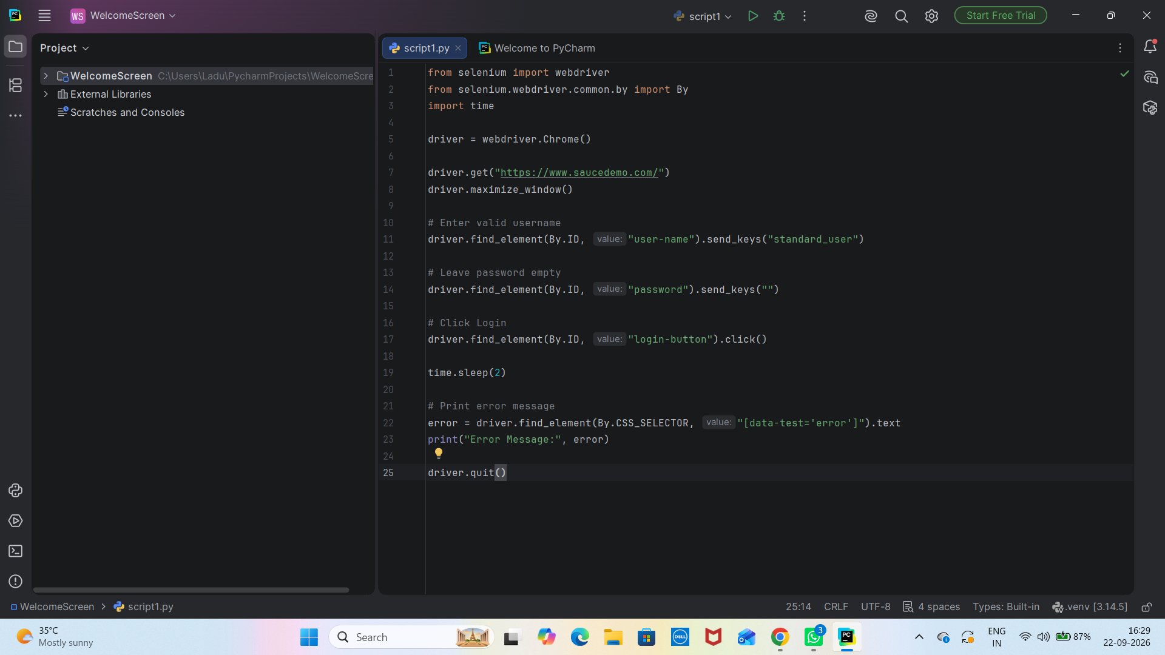

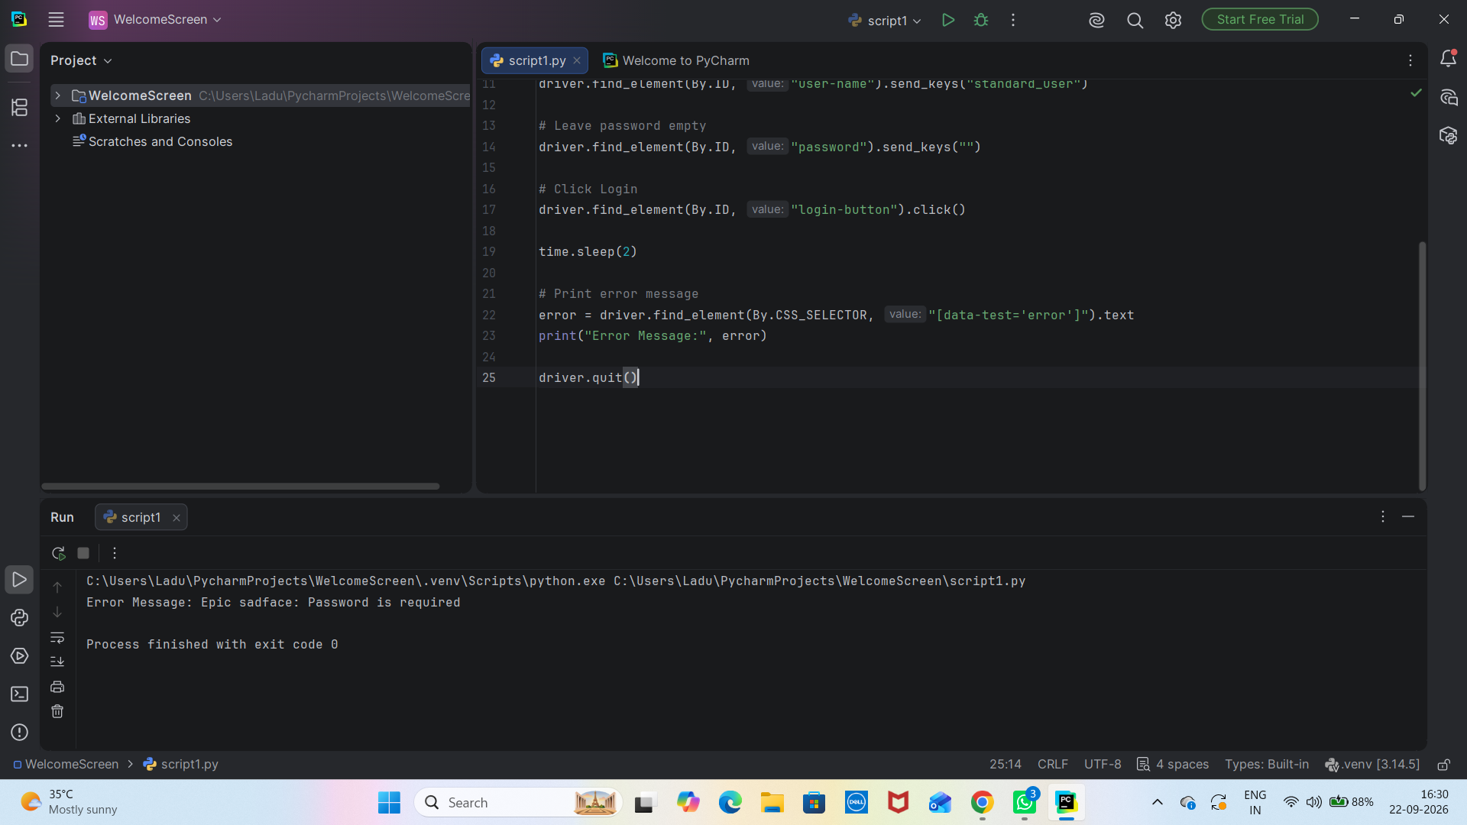
Scenario ID : 5
Empty Username

Test Steps:

1. Open pyCharm app
2. Open PyCharm project
3. Open script.py
4. Install Selenium - Python- m pip install selenium
5. Import Selenium code
6. Open Chrome - https://the-internet.herokuapp.com/login
7. Navigate to form Authentication
8. Enter username & password
Username:
Password:wrong123
9. Click login and verify successful login
10. Verify the success message
11. Click logout
12. Run the complete python automation

Screenshots:

